Pandas Assignment

HEROES OF PYMOLI DATA ANALYSIS

Trong Nguyen



# Females Spend More

* Though it is true that there are male players than female players on the Heroes of Pymoli’s server, the purchasing analysis by gender shows that female players tend to spend more money on an item than male players in the game. The average purchase amount spent per female player for an item was $4.46 while the average male player was $4.06. I suggest we allocate more money to recurring female players.

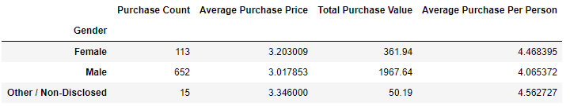

## The Goldilocks Sweet Spot (20-24)

* Our age demographics analysis shows that 44.79% of our players fall within the age range of 20 – 24 years of age. This data suggest that a lot of our players are either in college or have graduated high school. If we want our players to spend more money than we should customize our ads to target this market. Some suggestions would be to include more difficult levels or add more Rate R outfits or things that would entice people who fall within the 20 – 24 years of age range.

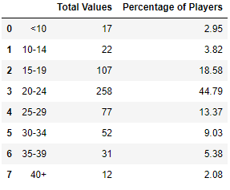

## Oathbreaker, Last Hope of the Breaking Storm $$$$$

* One noticeable trend we saw was that one particular item was extremely popular among the players. 12 players purchased Oathbreaker, and from these 12 players, they spent a total purchase value of $50.76 total. The item is not one of our cheaper items, so this shows that the item doesn’t have to be cheap for it to be popular. I would recommend creating more unique items with unique abilities so that we could charge more.

